Discover your Story at the FMS Scholastic Book Fair!
Reading is the most important skill you can teach a child. Of all the skills kids learn, it is the one you can influence the most.

Students will be visiting the in-school Book Fair with their ELA teacher one day between November 12th and 16th. On Thursday, November 15th from 5:30-7:00 p.m. we will be having a Family Shopping Coffeehouse Night. See the reverse side of this paper for details.

Our Online Book Fair is available for an extended time from November 9th to 29th. So even if you can’t make it to the Book Fair, we look forward to having you participate in our Online Fair. Remember, all online orders benefit our school and ship for FREE!

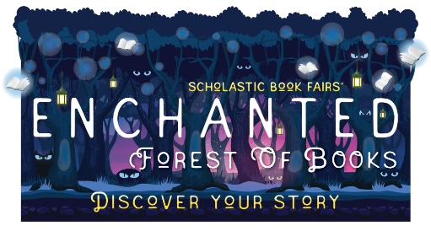
To find out more about the Book Fair or to start shopping, visit our homepage at: http://www.scholastic.com/bf/franklinmiddleschool14

Sincerely,
Ms. Samay (Library Media Specialist, asamay@bcps.org)
and Sandy White (PTA Vice-President, swhite.psyd@gmail.com)

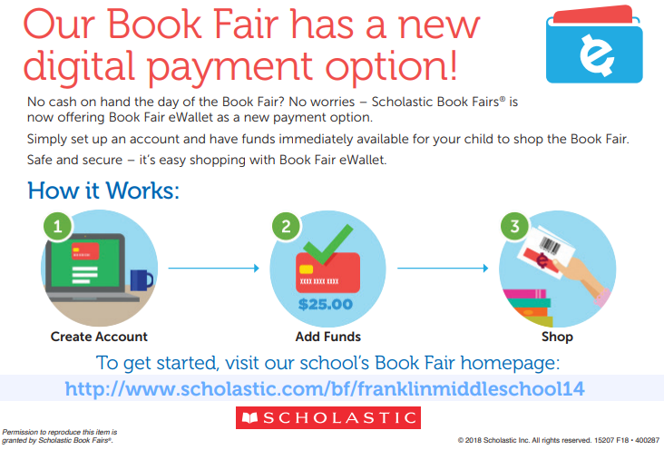
Parent Volunteers Are Needed. Please sign up to help at:
https://www.signupgenius.com/go/4090f4aadab23a75-fmsscholastic
My ELA Class is shopping at the Book Fair:
Date: ______________
Accepted forms of payment:
- Cash
- Check to FMS PTA
- Credit Card
- eWallet

