Please join us for an evening of shopping, entertainment and celebrating literacy at the  FMS Scholastic Book Fair & Coffeehouse Family Night  We are looking for student performers for Coffeehouse Night. Please complete the tear-off below and return it to Ms. Samay if you would like to perform or sign up online at: https://www.signupgenius.com/go/4090f4aadab23a75-fmsscholastic1 | 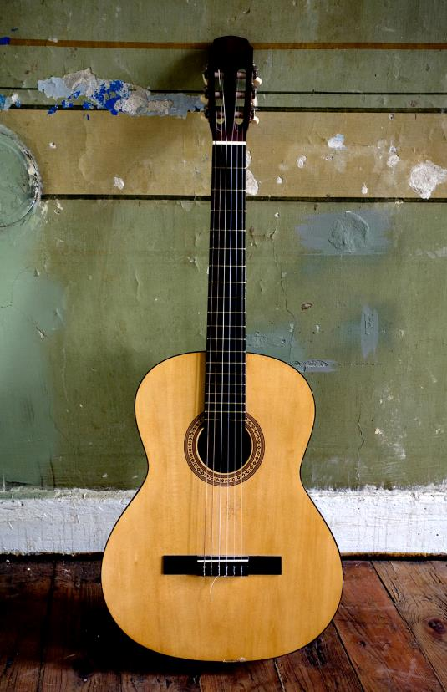  Date: November 15th  Time: 5:30-7:00p.m.  Location: FMS Library Media Center

Name: ________________________________ HR Teacher: _____________________________
Please circle what type of short performance (5 minutes or less) you would like to do.
Play an instrument Sing Read poetry or other writing Other
Description/Details: __________________________________________
Ms. Samay will contact you with other details and your scheduled performance time.

