**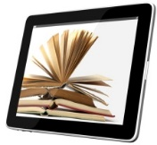**

eBooks for Everyone!

Whether you have access to a computer, smart phone, a tablet, an e-reader, or your school-issued HP device, there are free eBooks available to for you to read electronically 24/7. In fact, that’s why they’re called eBooks! Here is what you need to know to get started, so that you can have books available to read and use for class research, learning and study-- whenever you want to and wherever you are.

**ebooklogo.JPG**eBooks in Destiny include fiction novels, classics, graphic novels and nonfiction books. Just look for the “eBook” category on the main screen or the “Digital” category after searching for a book. You can also look for the symbol within the Destiny Discover catalog when doing a general search.

* ebooklogo.JPGAfter logging into Destiny Discover using your BCPS username and internal password, you can browse all of the eBooks that are available under the eBooks Featured Collections “ribbon.” Also, from any search page, you can click “Collections” on the top toolbar and select “eBooks.” You can also search for a specific eBook or a specific genre or topic that you want to read in eBook format in the Search blank. Your results list will indicate “digital” and display this symbol if the book is an eBook.
* You can open any available eBook to simply look at it, but if you want to check it out, you need to click on the Checkout button next to it. This will prevent someone else from coming along and checking it out before you do, and taking away your access for some amount of time!
* Some of the eBooks on Destiny Discover have a read aloud, text-to-speech feature. eBooks that include this feature will display a Play button playbutton.JPG at the bottom left side of the page.   
  If you click the Play button, you will hear a read-aloud of the page you have opened; this will be a computer-generated voice. (If you prefer more human sounding read-aloud voices, search for Audiobooks or PlayAways in Destiny or go to the TumbleBooks database, described later on this handout.)

General Directions for Using Destiny eBooks from Home:

To get started searching for an eBook on Destiny, you can go to [**http://destiny.bcps.org**](http://destiny.bcps.org) and choose our school. You can also access Destiny from the Digital Content tile in BCPSOne. There is also a mobile BryteWave K-12 app (on the HP Revolves) and a Destiny Discover app available for download from the App store or Google Play for your smartphone or tablet at home. If you downloaded the BryteWave app last year onto a home device, it can be updated to the Destiny Discover app for reading these eBooks on your device and/or downloading them onto smart phones and tablets. You will need to pick our state (MD) and our school from the list when you first sign on.

eBooks available from Digital Content tile in BCPS One

**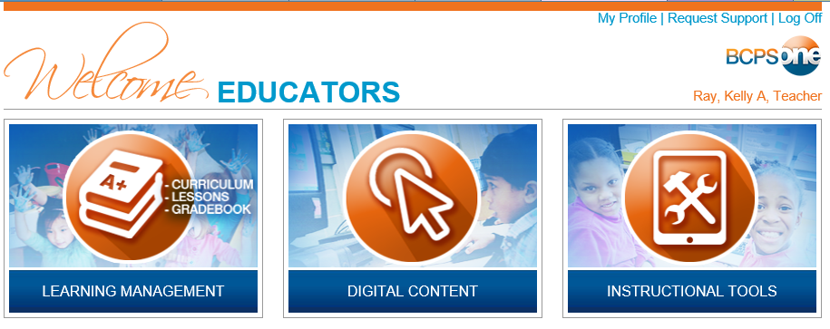**

TumbleBooks Cloud is a middle and high school collection of e-books, read-alongs, graphic novels, videos, and audio books that can be accessed online from the Digital Content tile in BCPSOne. On Tumblebooks Cloud, select the “Middle School” tab. Readers have the freedom to adjust the text size, line width and spacing, font style and color, the background color, and to highlight portions of a book and also add notes!

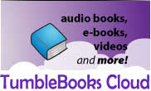 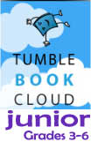   
 Gr. 6-12 Gr. 3-6   
The read-aloud features on Tumblebooks use real human voices, not computer generated speech-to-text. On Tumblebook Cloud Jr., you can find the read-aloud books under the categories “Read Alongs” and “Audiobooks,” although no text will show on the screen for the audiobooks. On Tumblebooks Cloud, the read aloud books can be found under the categories “Enhanced Ebooks” and “Audiobooks.” Again, the audiobooks will be sound only, no text display.

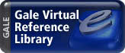

Gale Virtual Reference Library has eBook reference titles as well as many books from the DK Eyewitness series. Access to these eBooks is through the Destiny online library catalog or through BCPSOne. Once a student is logged into BCPSOne, he/she can access this database under the “Digital Content” button . [**http://bcpsone.bcps.org**](http://bcpsone.bcps.org)

**worldbook_advanced.gif**

World Book Advanced has an eBook Center with more than 125,000 titles in many languages, from American classics to world literature. Available for download to a variety of devices, it can be accessed from BCPSOne under the “Digital Content” tile.

****

Additional FREE e-Book Sources on the Internet

Baltimore Co. Public Library has access to a large collection of current and popular eBooks and audiobooks that maybe checked out and downloaded to a variety of devices for reading and listening. You will need a BCPL library card or SAIL card to check out eBooks from the public library. Browse the choices at [**http://www.bcpl.info/find-materials/downloadables-ebooks**](http://www.bcpl.info/find-materials/downloadables-ebooks)

International Children’s Digital Library has a collection of over 4500 free e-books in 61 languages, with users from over 220 countries. E-books can be searched by language, country, author, title or keywords. All titles have a summary and full color page reproduction, and many titles are multilingual. Explore a whole world of international children’s e-books at [**http://en.childrenslibrary.org/index.shtml**](http://en.childrenslibrary.org/index.shtml)

Project Gutenberg is an ambitious project which aims to provide as many eBooks in as many formats as possible for the entire world to read in as many languages as possible! Books are available for download in many formats, and many have full color page reproduction. You can access their collection of children’s e-books here: [**http://www.gutenberg.org/wiki/Category:Children%27s\_Bookshelf**](http://www.gutenberg.org/wiki/Category:Children%27s_Bookshelf)

**Lit2Go** is a free online collection of children’s stories and poems in audio book (Mp3) format that also has the full text of selections. An abstract, citation, playing time, and word count are given for each of the passages. [**http://etc.usf.edu/lit2go/**](http://etc.usf.edu/lit2go/)

DigiLibraries is a source of free eBooks that has a vast range of titles in digital format, and the collection is growing all the time. It has a mix of classics and recently published books. There are separate sections for Juvenile Fiction and Juvenile Nonfiction, with over 2500 titles just for kids. [**http://www.digilibraries.com/category/23/Juvenile\_Fiction/**](http://www.digilibraries.com/category/23/Juvenile_Fiction/)